Diedre Graham

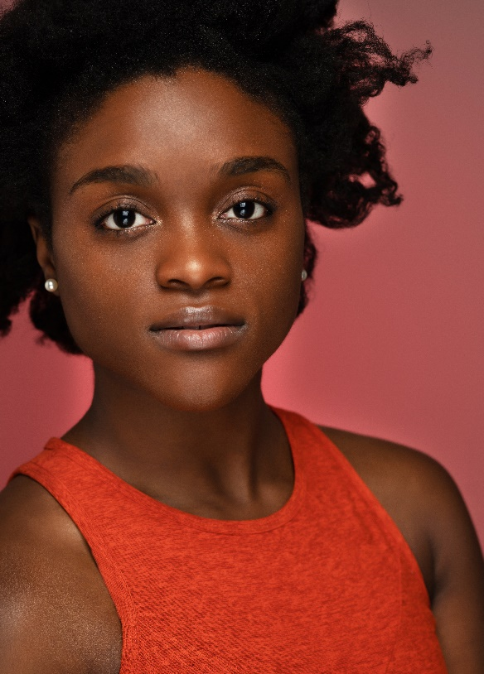
Diedre Graham is a native of Mobile, Alabama. At the age of 6, Diedre began her dance career at Prima Theatre for the Arts. It was there that she cultivated her love for ballet, jazz, tap and musical theater. As a product of the public school system, she went on to display her passion for dance at Dunbar Magnet School, Phillips Preparatory School and Murphy High School. While in high school, she created Imagine Me: Image in Me, which is an organization designed to raise awareness about body image and self-esteem through dance for girls between the ages of 12-18.

Diedre is a Fall 2013 graduate of the University of Alabama with a major in Dance and doubleminors in German and Anthropology. While enrolled at UA, Diedre studied abroad in China and Germany. She distinguished herself academically and artistically as an ABT (American Ballet Theatre) Scholarship Recipient and the recipient of several dance honors from the University of Alabama Department of Theater and Dance.

After graduating, Diedre accepted a position as a teacher in the Mobile County Public System. And, she became a member of Sanspointe Dance Company. She was also commissioned to perform a pas de deux choreographed by Sarah Barry in Danceform’s 70th International Choreographers’ Showcase at the Edinburgh Festival Fringe. In 2016, Diedre started building her dance for film experience as a ‘Ring Shout’ dancer in “ROOTS”. During the holiday season, she completed a contract with Busch Gardens Williamsburg Christmas Town as a dancer in the show “Miracles”. Under the direction of Angel Kaba, she received the opportunity to perform for the city of New York’s Department of Citywide Administrative Services’ Black History Month Program, “Love is Love” Choreographers Showcase, and STEPS Beyond Foundation presents “Choreography in Uncertain Times” performance lab. Currently, she is working on a piece that will be performed in Broadway Bares choreographed by Olivia Cipolla.

Diedre’s dance training is diverse and includes training at the Alvin Ailey American Dance Theater's summer intensive, American Ballet Theatre's summer intensives, Broadway Dance Center, Sheffield School of the Dance, Peridance, Gotta Dance Atlanta, STEPS on Broadway, Dance 411, and Atlanta Ballet. She also participated in a project with noted choreographers Chris Judd, Dave Scott, and Eddie Garcia. Also, she was a finalist with ALBA Berlin’s Dance Team in Berlin, Germany. Diedre was a member of the pre-professional company Alabama Repertory Dance Theater (four years) at the University of Alabama and the student-choreographed Dance Alabama semi-annual shows. Additionally, Diedre served as both a performer and choreographer in the Actor's Charitable Theater's production of The Color Purple. Currently, she is continuing her dance training in New York City including studying under Shernita Anderson, Olivia Cipolla, Jessica Castro, Aisha Francis, Galen Hooks, Charles Smith,. Also, she is working on her Master of Public Administration through Penn State’s World Campus. After completing her degree, she plans on owning and running an international dance nonprofit organization.

